Tosnaitheoirí [Leibhéal 2]

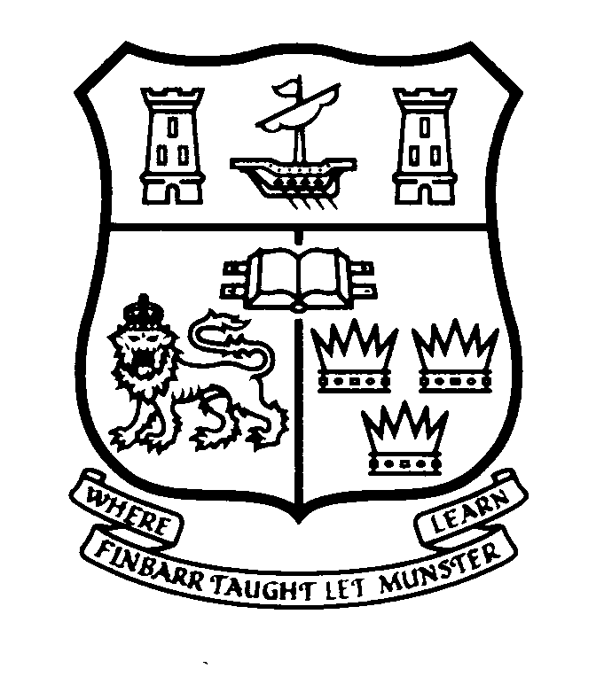 | Ionad na Gaeilge Labhartha  Áras Uí Rathaille, Coláiste na hOllscoile Corcaigh  www.ucc.ie/igl , Teil: 021-4902314, Ríomhphost: g.labh@ucc.ie
Cúrsa do Thosnaitheoirí sa Ghaeilge Labhartha 2026 – 2027
Beginners’ Course in Spoken Irish [Level 2]
20 Week Course
Dé Céadaoin / Wednesday 7.00 - 9.00 p.m.
Starting on Wednesday 23/09/2026
Foirm Iarratais - Application Form

Please use CAPITAL LETTERS
1. AINM (name)
SEOLADH
(Address)
2. Teagmhála (Contact No.):
Ríomhphost (e-mail):
Rogha Teagmhála: |  |  |  |  | Ríomhphost (e-mail) |  |  |  |  |  |  |  |  |  |  |  |  |  |  |  |  |  |  |  |  |  |  |  |  | An Post
(Preference for correspondence)
Náisiúntacht (Nationality):
Gairm Bheatha (Occupation):
Dáta breithe (Date of birth):
3. | Please return completed application form to g.labh@ucc.ie by Monday 24th August 2026 The course fee can be paid online [see details below].
4. | Course fee: |  |  | €250.00 per person
 |  |  |  | €200.00 concessionary rate
 | You can pay online. We also accept cash or cheque.

Bank Details UCC: | Name on the account: | UCC Direct Debits & Standing Orders
 | IBAN number: | IE05 BOFI 902768 730 26922
 | BIC/Swift address: | BOFIIE 2DXXX
NB: | PLEASE USE REFERENCE: | Gge+name+1120NA
 | Please send ‘Proof of Payment’ to us by e-mail g.labh@ucc.ie

DON OIFIG AMHÁIN | Admháil
 | Díolta: €
Ceadaím d’Ionad na Gaeilge Labhartha an t-eolas seo a choimeád go ceann bliana ar mhaithe le riaradh an chúrsa seo amháin.

